**Software Requirements Specifications (SRS)**

**ERP Solution for Lakhsma Sweater Ltd.**

REFERENCE: GW/ERP/SRS/Commercial

**Version: 1.0**

**Date of Release: November 03, 2015**



**Genweb2 Limited**

TK Bhaban (11th Floor),

13 Kazi Nazrul Islam Avenue,

Kawran Bazar, Dhaka 1215, Bangladesh

web: [http://www.genweb2.com](http://www.genweb2.com/)

**Contents**

Document Release History 4

1.0 Introduction 5

1.1 Purpose of SRS 5

2.0 Commercial 6

2.1 Overview 6

2.2 Functional features of Commercial modules are given below (actor wise) 6

2.3 Commercial Process flow 6

2.4 User Class 7

3.0 Process Flow: 8

3.1 Sales Contact Process Details: 8

3.2 Master LC Process details: 9

3.3 TT Process Export: 10

3.4 Import LC Process: 11

3.5 BBLC Process: 12

3.6 TT Process Import: 13

4.0 USE CASE Diagram 14

4.1 Export Sales Contact Process 14

4.2 Master Export LC Process: 14

4.3 Import BB LC Process: 15

4.4 TT Payment Process: 15

4.5 TT Receive Process: 16

5.0 USE CASE Details 17

5.1 UC/COM/001/ Receive Sales Contract: 17

5.2 UC/COM/002/ Receive Master LC: 18

5.3 UC/COM/003/ Convert Sales Contract to Master LC 19

5.4 UC/COM/004/ Amendment of Master LC 20

5.5 UC/COM/005/ Create Export Commercial Invoice 21

5.6 UC/COM/006/ Edit/Modify Export Commercial Invoice 22

5.7 UC/COM/007/ Submit Export Invoice 23

5.8 UC/COM/008/ Negotiate Bill 24

5.9 UC/COM/009/ Realize Export Invoice 25

5.10 UC/COM/010/ Receive Proforma Invoice from Supplier 26

5.11 UC/COM/011/ Apply to Open Import/BBLC 27

5.12 UC/COM/012/ Open Import LC 27

5.13 UC/COM/013/ Receive Import Commercial Invoice 28

5.14 UC/COM/014/ Declare Acceptance 29

5.15 UC/COM/015/ Pay against Import Invoice 30

5.16 UC/COM/016/ Force Loan 31

5.17 UC/COM/017/ Payment by TT (Advance) 32

5.18 UC/COM/018/ Payment by TT (Adjustment) 33

5.19 UC/COM/019/ Payment by TT (Full Payment) 34

5.20 UC/COM/020/ Payment Receive by TT (Advance) 34

5.21 UC/COM/021/ Payment Receive by TT (Adjustment) 35

5.22 UC/COM/022/ Payment Receive by TT (Full Payment) 36

6.0 Merchandising mock-up 37

6.1 Sales Contract 37

6.2 Master LC 37

6.3 Export Invoice 38

6.4 Export Invoice Submission 38

6.5 Export Invoice Realization 39

6.6 TT Receive 40

6.7 Proforma Invoice 41

6.8 BB LC/Import LC 42

6.9 Import Invoice 43

6.10 Import Payment 44

6.11 TT Payment 45

Document Release History

| Sl. No. | Version Number | Release Date | Prepared By | Reviewed By | Approved By | Reasons for New Release |
| --- | --- | --- | --- | --- | --- | --- |
| 1 | 1.0 | 3rd Nov, 2015 | Nazifa Chowdhury |  | N/A |  |
|  |  |  |  |  |  |  |

# Abbreviation

BB LC – Back to Back Letter of Credit

CI- Commercial Invoice

Inco – International Commercial

LC – Letter of Credit

PO – Purchase Order

PI – Proforma Invoice

SC – Sales Contracts

TT – Telegraphic Transfer

# Introduction

## Purpose of SRS

The purposes of this SRS are to clearly identify the customer requirements and provide a detailed document. The customer will review the document and approve/make change as required. It will also help the review team to be able to validate whether the customer requirements has been fulfilled.

The SRS will also help the Analyst and Designer to understand and track the Requirements for the proposed system. It will also identify a set of requirements for the Development of the project. The SRS helps to describe the behavior of the system to be developed.

# Commercial

## Overview

## Domestic sales procedure and international sales procedure is different thing. Commercial department works for resolving the issues where Buyers and Sellers are from different countries and they needs to be ensured about the product and payment. Commercial (Export & Import) department handles all the internationally accepted procedures to make sure successful international sales and purchase. Now a days some procedures like LC became popular for domestic sales also, Commercial department handle that type of scenarios also. The commercial module of ERP application will be able to manage that kind of foreign sales and purchase process.

## Functional features of Commercial modules are given below (actor wise)

* Receive Sales Contract
* Receive Master/Export LC
* Convert Sales Contract to Master/Export LC
* Create Export Commercial Invoice
* Submit Export Commercial Invoice for Realization
* Submit Export Commercial Invoice for Negotiation
* Realize Export Commercial Invoice
* Receive Advance TT from Buyer
* Receive adjustment TT from Buyer
* Receive Full Payment through TT from Buyer
* Receive Proforma Invoice from Supplier
* Apply for Import LC
* Apply for BBLC
* Open Import LC
* Open BBLC
* Receive Import Commercial Invoice
* Import Invoice bill payment
* BBLC Invoice bill payment
* Advance bill payment to Supplier through TT
* Adjusted bill payment to Supplier through TT
* Full bill payment to Supplier through TT

## Commercial Process flow

Commercial process flow consists:

* Sales contract process
* Master/Export LC process
* Import LC process
* BB LC process
* TT process for Export
* TT process for Import

## User Class

|  |  |  |
| --- | --- | --- |
| User Class/Actor | Characteristics | Responsibilities |
| Commercial Officer | * Lien Master/Export LC * Create Export Commercial Invoice * Submit Export Invoice * Open Import LC * Open BBLC * Provide acceptance * Receive Import Commercial Invoice | * Add, modify documents * Maintain other documents related information |
| Procurement Officer | * Receive Proforma Invoice from Supplier | * Add, modify documents * Maintain other documents related information |
| Storekeeper | * Receive goods against import Commercial Invoice | * Add, modify documents * Maintain other documents related information |
| Finance Officer | * Submit Export invoice for Negotiation * Realize Export Invoice * Import LC Bill Payment * BBLC Bill payment * Receive TT Payment from Buyer * TT Payment to Supplier | * Add, modify documents * Maintain other documents related information |
| Super admin | * Can do any jobs in system | * Add, modify and delete all information. * Give permission to all users and documents. * Manage the user authentication layer. * Create & assign role to users. * Manage application security. * Manage application settings. |

# Process Flow:

## Sales Contact Process Details:

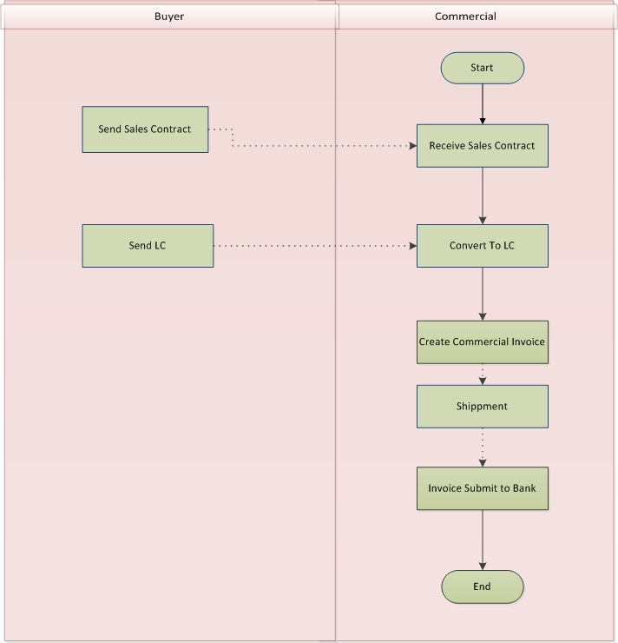

Fig: Sales Contact Process

**Sales Contract Process:**

* Buyer sends Sales contract as a Confirmation of the Export Orders
* Commercial officer receives that Sales Contract
* Export PO get tagged with the Sales Contract
* Buyer Gives Master/Export LC before shipment to replace Sales Contract
* Sales Contract gets converted to Export/master LC
* Sales Contract gets eliminate then
* It contains the regular Export LC process

## Master LC Process details:

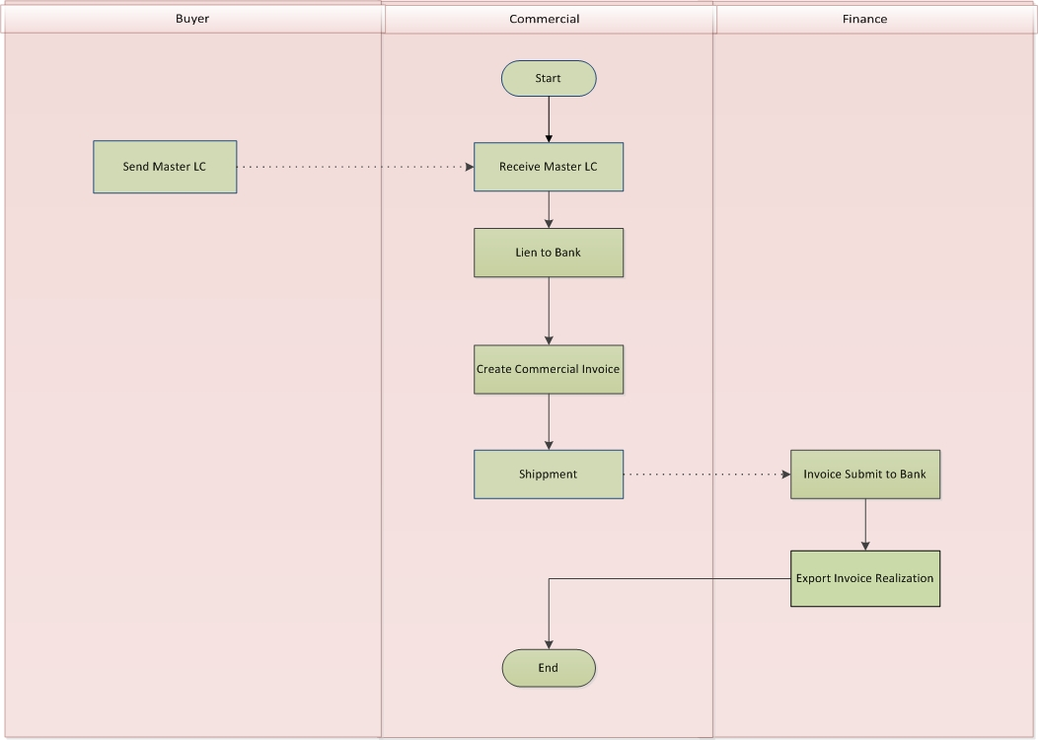

Fig: Master LC Process

**Master LC Process:**

* Buyer gives Master/Export LC
* Commercial Officer lien the Master/Export LC
* Export PO get tagged with the Sales Contract
* Sales Contract may get converted to Master/Export LC
* Commercial Officer creates Export Commercial Invoice against master/Export LC
* Commercial Officer can Submit Export Commercial Invoice for Submission or Negotiation
* Finance Officer distribute the Negotiate amount and charges for Invoice Submission for Negotiation
* Finance Officer distributes the realized amount to the respective accounts
* Finance Officer deducts the changes (If any) from the realized amount
* Finance Officer can pays LC related charges from other respective accounts

## TT Process Export:

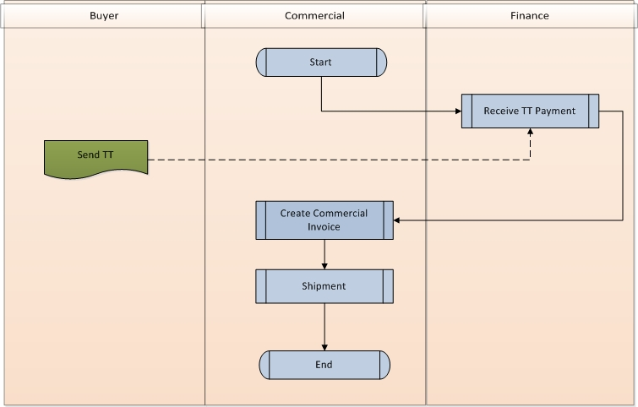

Fig: TT Process (Export)

**TT Process for Export:**

* Buyer pays advance payment as advance through TT
* Finance Officer receives the TT payment from Bank
* Commercial Officer creates the Export Invoice
* After shipment Buyer pays the adjusted amount
* Buyer can pays the full payment through TT after shipment

## Import LC Process:

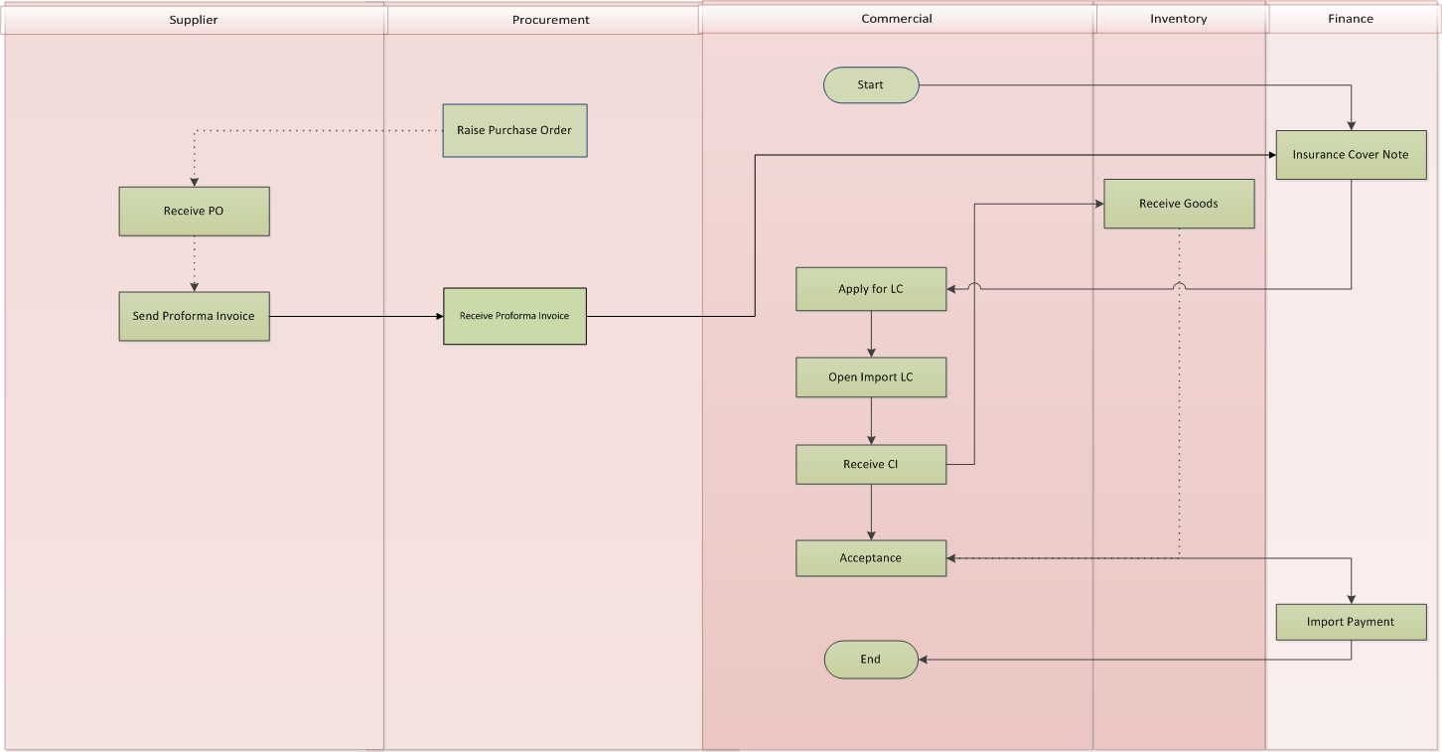

Fig: Import LC Process

**Import LC Process**

* Purchase authority issue Purchase Order for Import
* Purchase authority receives Proforma Invoice from the Supplier against the given Purchase Order
* Finance Officer arrange Insurance Cover Note for Proforma Invoice
* Commercial Officer apply to Bank for opening Import LC
* Commercial Officer receive Import Commercial Invoice from Supplier
* Commercial Officer gives acceptance for the Import Commercial Invoice
* Finance Officer pays the Import bill against the Import Commercial invoice

## BBLC Process:

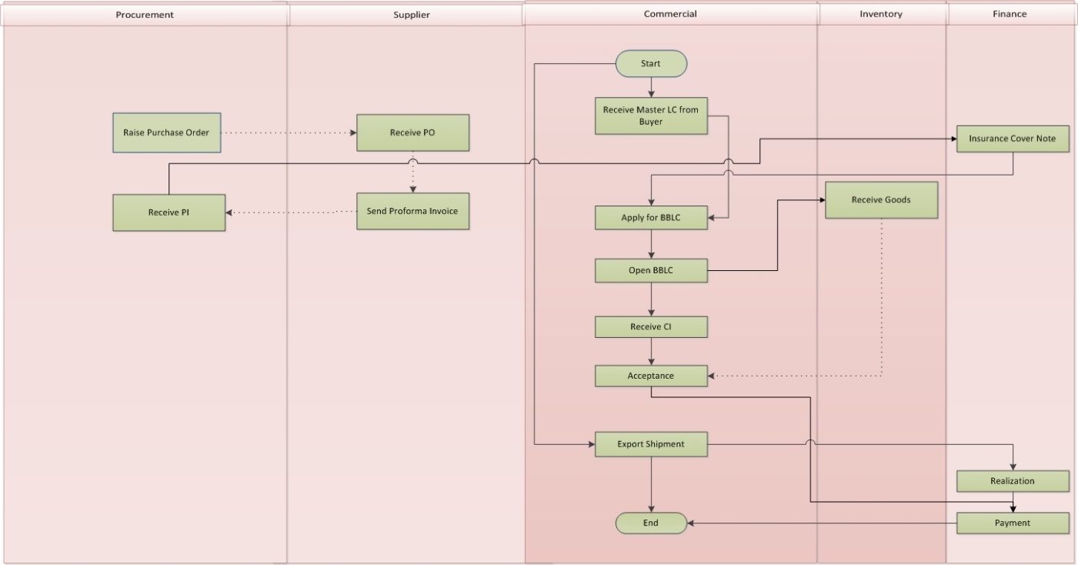

Fig: BBLC Process

**BBLC Process**

* Commercial Officer receive Master/Export LC from Buyer
* Purchase authority issue Purchase Order for Import raw materials
* Purchase authority receives Proforma Invoice from the Supplier against the given Purchase Order
* Finance Officer arrange Insurance Cover Note for Proforma Invoice
* Commercial Officer apply to Bank for open BBLC against the related Master/Export LC
* Commercial Officer receive Import Commercial Invoice from Supplier
* Commercial Officer gives acceptance for the Import Commercial Invoice
* Finance officer receive the payment of Master/Export LC
* Bank pay the Import bill against the Import Commercial invoice from the realized amount from Export

## TT Process Import:

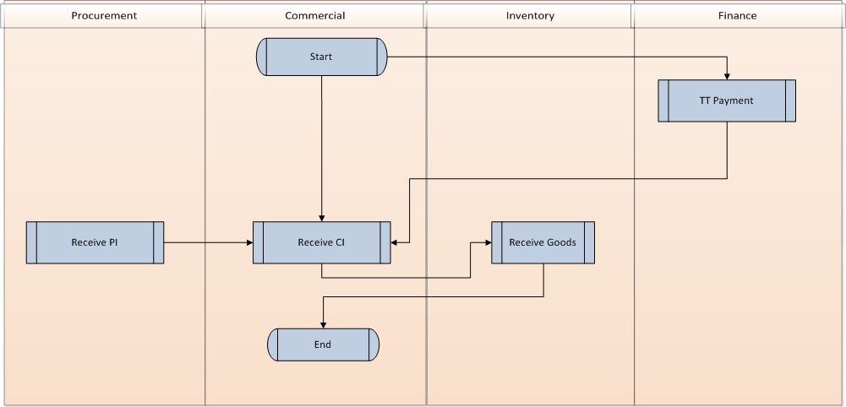

Fig: TT Process (Import)

**TT Process for Import:**

* Supplier are getting paid as advance through TT by the Finance Officer for respective Order
* Commercial Officer receives the import Invoice
* After shipment adjusted amount will be paid to supplier through TT
* Supplier can be paid full payment through TT after shipment

# USE CASE Diagram

## Export Sales Contact Process

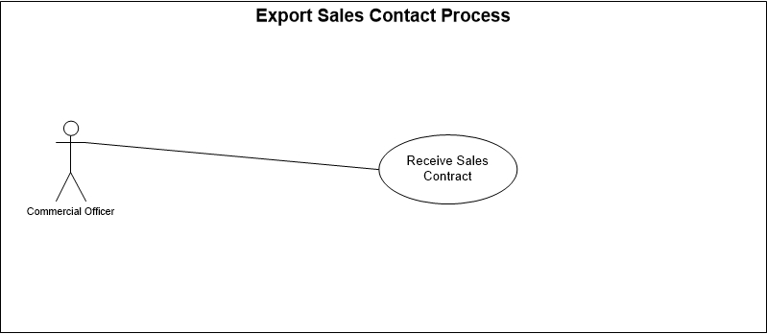

Fig: Export Sales Contact use case

## Master Export LC Process:

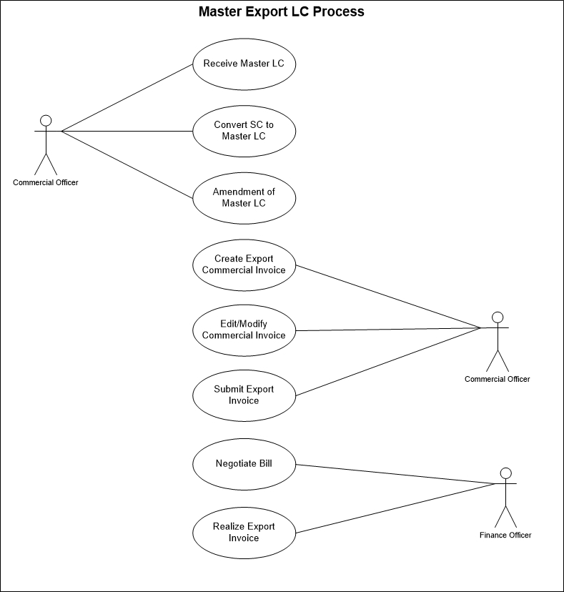

Fig: Master Export LC process use case

## Import LC Process:

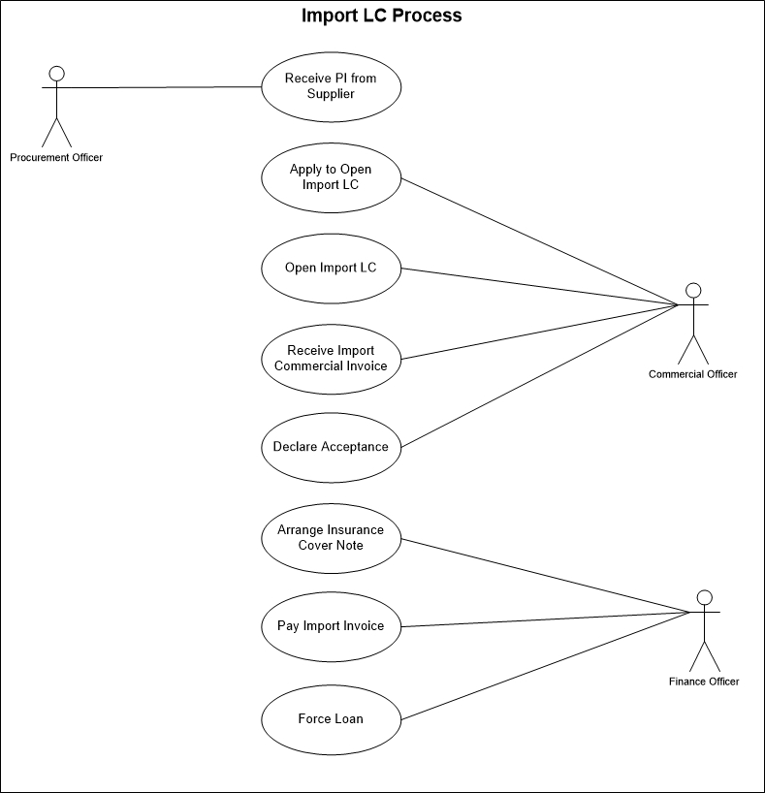

Fig: Import LC process use case

## BB LC Process

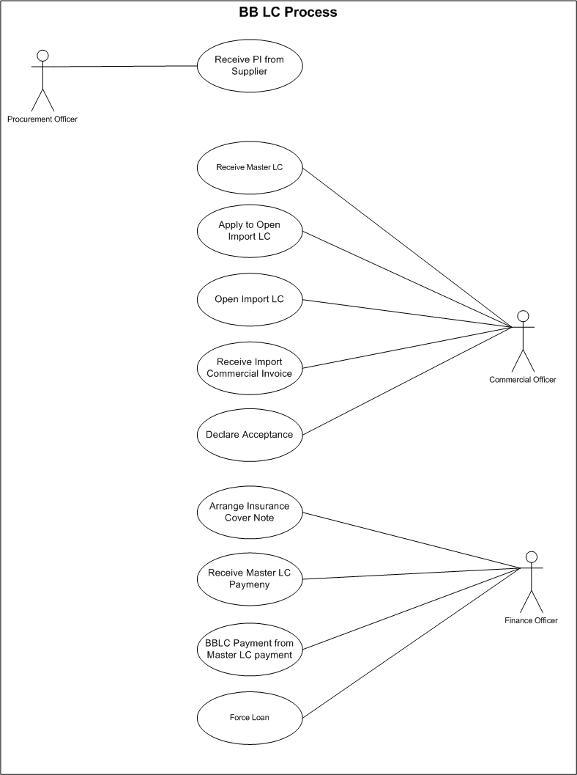

## TT Payment Process:

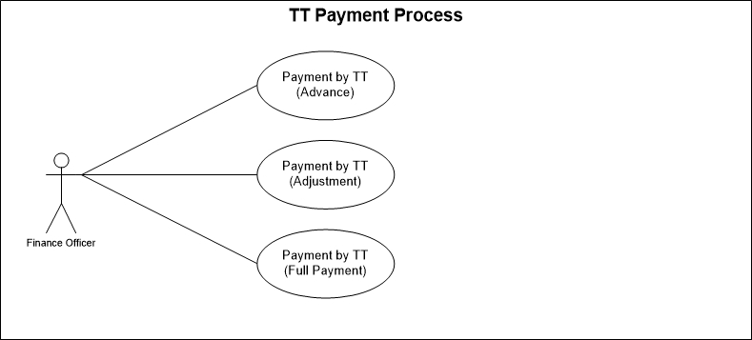

Fig: TT Payment Process use case

## TT Receive Process:

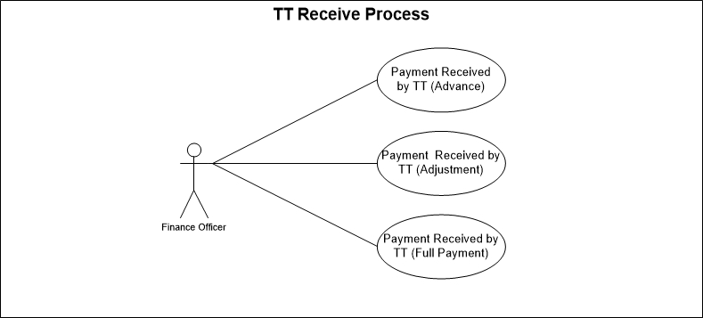

Fig: TT Receive Process use case

# USE CASE Details

## UC/COM/001/ Receive Sales Contract:

|  |  |  |
| --- | --- | --- |
| Use Case ID: UC/COM/001 | | |
| Use Case Name**: Receive Sales Contract** | | |
| Created By: **GenWeb2 Ltd.** | | Date Created: 3 November, 2015 |
| Actors: | * Commercial Officer | |
| Trigger: | * When Commercial Officer receive Sales Contract from Buyer | |
| Business Rule | * Buyer gives Sales Contract for tagging Purchase order with it * Sales Contract is a base document to proceed for any order * LC will be given at later stage to replacing Sales Contract | |
| Description: | Buyer gives Sales Contract as a confirmation of Order(s). Export PO(s) are getting tagged with Sales Contract. Buyer gives the Master LC before Shipment. Eventually Buyer can skip the Sales Contract Process | |
| Frequency of Use | * Medium (Regularly) | |
| Preconditions | * Buyer must be exist in System. * Bank must be exist in System * Payment Terms must be exist in System * Inco Terms must be exist in System * Export PO must exist in System | |
| Post Conditions | * Appropriate message will be displayed after each entry being saved / updated. * Sales Contract will allow to tag more pending PO in later stage * Tagged PO will not be allowed to tag anymore | |
| Assumption | * N/A | |
| Goal | Record Sales Contract in System | |
| Normal Flow | * Buyer give Sales Contract as Order Confirmation * Commercial Officer lien the Sales Contract * All terms and conditions are declared in Sales Contract * Export POs are getting tagged in Sales Contract | |
| Alternate Flow | N/A | |
| Exception | * Proper message should be displayed if Sales Contract can’t be saved. * Proper message should be displayed if any master or dependent data is missing or not found. * Appropriate message should be displayed if mandatory fields are not filled. * Any system exception/Application exception should be handled centrally with proper user message during the page browse/save/update/view operations. | |
| Cross Reference | * N/A | |

## UC/COM/002/ Receive Master LC:

|  |  |  |
| --- | --- | --- |
| Use Case ID: UC/COM/002 | | |
| Use Case Name**: Receive Master LC** | | |
| Created By: **GenWeb2 Ltd.** | | Date Created: 03 November, 2015 |
| Actors: | * Commercial Officer | |
| Trigger: | * When Commercial Officer receive Master/Export LC from Buyer | |
| Business Role | * Buyer gives Master/Export LC for shipping the Orders * Commercial Officer Lien the Master LC in his bank * Back to Back LC can be opened against Master LC to import the raw materials for production | |
| Description: | Buyer gives Master/Export LC for most secure shipment. Export PO(s) are getting tagged with Master/Export LC. Commercial authority lien the LC in their Bank. Master LC contains all shipment related terms and conditions. Bank of both parties are taking the liabilities in assure smooth shipment and payment guarantee | |
| Frequency of Use | * Medium (Regularly) | |
| Preconditions | * Buyer must be exist in System. * Bank must be exist in System * Payment Terms must be exist in System * Inco Terms must be exist in System * Export PO must exist in System | |
| Post Conditions | * Appropriate message will be displayed after each entry being saved / updated. * Master/Export LC will allow to tag more pending PO in later stage * Tagged PO will not be allowed to tag anymore * BBLC can be opened against the Master/Export LC | |
| Assumption | * N/A | |
| Goal | Record Master/Export LC in System | |
| Normal Flow | * Buyer gives Master/Export LC for order shipment * Commercial Officer Lien the Master/Export LC * All terms and conditions are declared in Master/Export LC * Export POs are getting tagged in Master/Export LC | |
| Alternate Flow | N/A | |
| Exception | * Proper message should be displayed if Master LC can’t be saved. * Proper message should be displayed if any master or dependent data is missing or not found. * Appropriate message should be displayed if mandatory fields are not filled. * Any system exception/Application exception should be handled centrally with proper user message during the page browse/save/update/view operations. | |
| Cross Reference | * N/A | |

## UC/COM/003/ Convert Sales Contract to Master LC

|  |  |  |
| --- | --- | --- |
| Use Case ID: UC/COM/003 | | |
| Use Case Name**: Convert Sales Contract to Master LC** | | |
| Created By: **GenWeb2 Ltd.** | | Date Created: 03 November, 2015 |
| Actors: | * Commercial Officer | |
| Trigger: | * When Commercial Officer receive Master/Export LC from Buyer against any Sales Contract | |
| Business Role | * Buyer gives Sales Contract as a confirmation at the preliminary stage * Buyer gives Master/Export LC for shipping the Orders where Sales Contract was given earlier * Commercial Officer Lien the Master LC in his bank * Back to Back LC can be opened against Master LC to import the raw materials for production | |
| Description: | Buyer gives Sales Contract as a confirmation at the preliminary stage then Buyer gives Master/Export LC for those Export Orders before Shipment. Commercial authority lien the LC in their Bank. Master LC contains all shipment related terms and conditions. Sales Contract gets invalid as no use of it for converted LCs. Bank of both parties are taking the liabilities in assure smooth shipment and payment guarantee | |
| Frequency of Use | * Medium (Regularly) | |
| Pre-conditions | * Sales Contract Must be exist in System * Buyer must be exist in System. * Bank must be exist in System * Payment Terms must be exist in System * Inco Terms must be exist in System * Export PO must exist in System | |
| Post Conditions | * Appropriate message will be displayed after each entry being saved / updated. * Master/Export LC will allow to tag more pending PO in later stage * Tagged PO will not be allowed to tag anymore * BBLC can be opened against the Master/Export LC * Converted Sales Contract will be available for any further use | |
| Assumption | * N/A | |
| Goal | To Convert Master LC from Sales Contract | |
| Normal Flow | * Buyer gives Sales Contract at the preliminary contract * Buyer gives Master/Export LC for order shipment as a replacement of the Sales Contract * Commercial Officer Lien the Master/Export LC * All terms and conditions are declared in Master/Export LC * Export POs are getting tagged in Master/Export LC * BBLC can be opened against the Master/Export LC | |
| Alternate Flow | N/A | |
| Exception | * Proper message should be displayed if Conversion not possible. * Proper message should be displayed if any master or dependent data is missing or not found. * Appropriate message should be displayed if mandatory fields are not filled. * Any system exception/Application exception should be handled centrally with proper user message during the page browse/save/update/view operations. | |
| Cross Reference | * Use Case ID: UC/COM/001 | |

## UC/COM/004/ Amendment of Master LC

|  |  |  |
| --- | --- | --- |
| Use Case ID: UC/COM/004 | | |
| Use Case Name**: Amendment of Master LC** | | |
| Created By: **GenWeb2 Ltd.** | | Date Created: 03 November, 2015 |
| Actors: | * Commercial Officer | |
| Trigger: | * When Buyer amend any Master LC and the commercial officer address it | |
| Business Role | * Buyer gives Master/Export LC for Export order * Buyer may change the LC Value, LC expiry Date, Commercial Officer address the amendment * Master/Export LC will be updated | |
| Description: | * Buyer gives Master/Export LC for Export order in the middle Buyer may change the LC Value, LC expiry Date, Commercial Officer address the amendment so Master/Export LC will be updated | |
| Frequency of Use | * medium | |
| Pre-conditions | * Master/Export LC must exist * Buyer must provide amendment * Master/Export LC status can’t be Close | |
| Post Conditions | * Appropriate message will be displayed after each entry being saved / updated. * LC Value, LC expiry date will be updated as per amendment | |
| Assumption | * N/A | |
| Goal | To enter LC amendment in System | |
| Normal Flow | * Buyer gives Master/Export LC for Export order * Buyer may change the LC Value, LC expiry Date * Commercial Officer address the amendment * Master/Export LC information will be updated as per amendment | |
| Alternate Flow | N/A | |
| Exception | * Proper message should be displayed if Conversion not possible. * Proper message should be displayed if any master or dependent data is missing or not found. * Appropriate message should be displayed if mandatory fields are not filled. * Any system exception/Application exception should be handled centrally with proper user message during the page browse/save/update/view operations. | |
| Cross Reference | * UC/COM/002 | |

## UC/COM/005/ Create Export Commercial Invoice

|  |  |  |
| --- | --- | --- |
| Use Case ID: UC/COM/005 | | |
| Use Case Name**: Create Export Commercial Invoice** | | |
| Created By: **GenWeb2 Ltd.** | | Date Created: 03 November, 2015 |
| Actors: | * Commercial Officer | |
| Trigger: | * When Commercial Officer create Commercial Invoice for Export order | |
| Business Role | * Buyer gives Export Order and LC for shipment * After successful production commercial officer create Commercial Invoice for shipping the goods * Based on the Commercial Invoice exporters will receive the payment for the shipment | |
| Description: | Buyer gives Export Order and as a shipment guarantee buyer gives Master/Export LC to the exporter. Exported produce the goods and to ship the goods exporter create the Commercial Invoice as the bill of shipped goods. This is the base document after shipment. Both parties have their financial transaction based on that Commercial Invoice | |
| Frequency of Use | * Medium (Regularly) | |
| Pre-conditions | * Buyer must be exist in System. * Bank must be exist in System * Payment Terms must be exist in System * Inco Terms must be exist in System * Export PO must exist in System * Export LC must exist in System | |
| Post conditions | * Appropriate message will be displayed after each entry being saved / updated. * Commercial Invoice can be created next time up to the maximum level of the Export LC value * Created Commercial Invoice will be available for submit to Bank | |
| Assumption | * N/A | |
| Goal | To create export Commercial Invoice in System | |
| Normal Flow | * Buyer gives Export Order and LC for shipment * After successful production commercial officer create Commercial Invoice for shipping the goods * Commercial Officer submit the Commercial Invoice to Bank for Realization | |
| Alternate Flow | N/A | |
| Exception | * Proper message should be displayed if Commercial Invoice can’t be saved. * Proper message should be displayed if any master or dependent data is missing or not found. * Appropriate message should be displayed if mandatory fields are not filled. * Any system exception/Application exception should be handled centrally with proper user message during the page browse/save/update/view operations. | |
| Cross Reference | * Use Case ID: UC/COM/002 | |

## UC/COM/006/ Edit/Modify Export Commercial Invoice

|  |  |  |
| --- | --- | --- |
| Use Case ID: UC/COM/006 | | |
| Use Case Name**: Edit/Modify Export Commercial Invoice** | | |
| Created By: **GenWeb2 Ltd.** | | Date Created: 03 November, 2015 |
| Actors: | * Commercial Officer | |
| Trigger: | * When Commercial Officer Edit/update Commercial Invoice for Export order | |
| Business Role | * Buyer gives Export Order and LC for shipment * After successful production commercial officer create Commercial Invoice for shipping the goods * Edit/Modification takes place for changes or update | |
| Description: | Buyer gives Export Order and as a shipment guarantee buyer gives Master/Export LC to the exporter. Exported produce the goods and to ship the goods exporter create the Commercial Invoice as the bill of shipped goods. If there is any mistake or update in document there it needs to be updated through Edit/Modify action | |
| Frequency of Use | * Medium (Regularly) | |
| Pre-conditions | * Export Invoice must exist in System * Related export Commercial Invoice should be unsubmitted | |
| Post conditions | * Appropriate message will be displayed after each entry being saved / updated. * Commercial Invoice will be updated accordingly as per the modification/update | |
| Assumption | * N/A | |
| Goal | To Edit/Modify export Commercial Invoice in System | |
| Normal Flow | * Buyer gives Export Order and LC for shipment * After successful production commercial officer create Commercial Invoice for shipping the goods * Commercial Officer edit/modify the Export Commercial Invoice for mistake or modification | |
| Alternate Flow | N/A | |
| Exception | * Proper message should be displayed if Commercial Invoice can’t be edit/Modified. * Proper message should be displayed if any master or dependent data is missing or not found. * Appropriate message should be displayed if mandatory fields are not filled. * Any system exception/Application exception should be handled centrally with proper user message during the page browse/save/update/view operations. | |
| Cross Reference | * Use Case ID: UC/COM/005 | |

## UC/COM/007/ Submit Export Invoice

|  |  |  |
| --- | --- | --- |
| Use Case ID: UC/COM/007 | | |
| Use Case Name**: Submit Export Invoice** | | |
| Created By: **GenWeb2 Ltd.** | | Date Created: 03 November, 2015 |
| Actors: | * Commercial Officer | |
| Trigger: | * When Commercial Officer Submit Export Commercial Invoice to Bank | |
| Business Role | * Buyer gives Export Order and LC for shipment * After successful production commercial officer create Commercial Invoice for shipping the goods * Commercial Officer submit the Export Commercial Invoice to Bank for realization of bill | |
| Description: | Buyer gives Export Order and as a shipment guarantee buyer gives Master/Export LC to the exporter. Exported produce the goods and to ship the goods exporter create the Commercial Invoice as the bill of shipped goods. Then Commercial officer submit the Export Commercial Invoice to Bank to realize the bill | |
| Frequency of Use | * Medium (Regularly) | |
| Preconditions | * Export LC must exist in System * Export Commercial Invoice must exist in System | |
| Post conditions | * Appropriate message will be displayed after each entry being saved / updated. * Commercial Invoice can be submitted to Bank only once | |
| Assumption | * N/A | |
| Goal | To record Export Commercial Invoice in System | |
| Normal Flow | * Buyer gives Export Order and LC for shipment * After successful production commercial officer create Commercial Invoice for shipping the goods * Commercial Officer submit the Commercial Invoice to Bank for Realization * Exporter realized the bill of submitted Commercial Invoice | |
| Alternate Flow | N/A | |
| Exception | * Proper message should be displayed if Export Commercial Invoice Submission can’t be saved. * Proper message should be displayed if any master or dependent data is missing or not found. * Appropriate message should be displayed if mandatory fields are not filled. * Any system exception/Application exception should be handled centrally with proper user message during the page browse/save/update/view operations. | |
| Cross Reference | * UC/COM/004 | |

## UC/COM/008/ Negotiate Bill

|  |  |  |
| --- | --- | --- |
| Use Case ID: UC/COM/008 | | |
| Use Case Name**: Negotiate Bill** | | |
| Created By: **GenWeb2 Ltd.** | | Date Created: 03 November, 2015 |
| Actors: | * Commercial Officer | |
| Trigger: | * When Commercial Officer Submit Export Commercial Invoice to Bank for bill Negotiation | |
| Business Role | * Buyer gives Export Order and LC for shipment * After successful production commercial officer create Commercial Invoice for shipping the goods * Commercial Officer submit the Export Commercial Invoice to Bank for realization of bill but have negotiation with bank to get loan against the submitted Commercial Invoice | |
| Description: | Buyer gives Export Order and as a shipment guarantee buyer gives Master/Export LC to the exporter. Exported produce the goods and to ship the goods exporter create the Commercial Invoice as the bill of shipped goods. Then Commercial officer submit the Export Commercial Invoice to Bank to realize the bill but have negotiation with bank to get loan against the submitted Commercial Invoice | |
| Frequency of Use | * Medium (Regularly) | |
| Pre-conditions | * Export LC must exist in System * Export Commercial Invoice must exist in System * Commercial Invoice Submission type must have to be Negotiation | |
| Post Conditions | * Appropriate message will be displayed after each entry being saved / updated. * Commercial Invoice can be submitted to Bank only once | |
| Assumption | * N/A | |
| Goal | To record Export Commercial Invoice(for submission type negotiation) in System | |
| Normal Flow | * Buyer gives Export Order and LC for shipment * After successful production commercial officer create Commercial Invoice for shipping the goods * Commercial Officer submit the Commercial Invoice to Bank for Realization where submission type is negotiation. * Negotiated amount will be distributed to the distribution accounts. * Negotiation charges will be charged from the accounts or will be deducted from the negotiation amount * Negotiated amount will be adjusted along with the interest (as per condition) while Commercial Invoice will be realized | |
| Alternate Flow | N/A | |
| Exception | * Proper message should be displayed if Export Commercial Invoice Submission for Negotiation can’t be saved. * Proper message should be displayed if any master or dependent data is missing or not found. * Appropriate message should be displayed if mandatory fields are not filled. * Any system exception/Application exception should be handled centrally with proper user message during the page browse/save/update/view operations. | |
| Cross Reference | * UC/COM/004 | |

## UC/COM/009/ Realize Export Invoice

|  |  |  |
| --- | --- | --- |
| Use Case ID: UC/COM/009 | | |
| Use Case Name**: Realize Export Invoice** | | |
| Created By: **GenWeb2 Ltd.** | | Date Created: 03 November, 2015 |
| Actors: | * Finance Officer | |
| Trigger: | * When Finance Officer Receive the realization amount against any Commercial Invoice Submission | |
| Business Role | * Buyer gives Export Order and LC for shipment * After successful production commercial officer create Commercial Invoice for shipping the goods * Commercial Officer submit the Export Commercial Invoice to Bank for realization. * Commercial Invoice get realized and Finance officer distribute the realized amount to suggested accounts. | |
| Description: | Buyer gives Export Order and as a shipment guarantee buyer gives Master/Export LC to the exporter. Exported produce the goods and to ship the goods exporter create the Commercial Invoice as the bill of shipped goods. Then Commercial officer submit the Export Commercial Invoice to Bank to realize the bill. Bank receive the bill from Buyer and Finance officer distribute the realized amount to suggested accounts | |
| Frequency of Use | * Medium (Regularly) | |
| Pre-conditions | * Export LC must exist in System * Export Commercial Invoice must exist in System * Commercial Invoice must be submitted | |
| Post Conditions | * Appropriate message will be displayed after each entry being saved / updated. * Only Submitted Commercial Invoice can be realized * Already Realized Commercial Invoice can’t be realized anymore * Negotiation amount will be adjusted in Commercial Invoice Submission type was Negotiation. | |
| Assumption | * N/A | |
| Goal | To record Export Commercial Invoice realization in System | |
| Normal Flow | * Buyer gives Export Order and LC for shipment * After successful production commercial officer create Commercial Invoice for shipping the goods * Commercial Officer submit the Commercial Invoice to Bank for Realization * Realized amount get distributed to the suggested accounts * Deductions are getting deducted from the realized amount * Charges are addressed from suggested accounts. * Negotiation amounts are getting adjusted if Commercial Invoice Submission type was Negotiation. | |
| Alternate Flow | N/A | |
| Exception | * Proper message should be displayed if Export Commercial Invoice Realization can’t be saved. * Proper message should be displayed if any master or dependent data is missing or not found. * Appropriate message should be displayed if mandatory fields are not filled. * Any system exception/Application exception should be handled centrally with proper user message during the page browse/save/update/view operations. | |
| Cross Reference | * UC/COM/005 | |

## UC/COM/010/ Receive Proforma Invoice from Supplier

|  |  |  |
| --- | --- | --- |
| Use Case ID: UC/COM/010 | | |
| Use Case Name**: Receive Proforma Invoice from Supplier** | | |
| Created By: **GenWeb2 Ltd.** | | Date Created: 03 November, 2015 |
| Actors: | * Procurement Officer | |
| Trigger: | * When Procurement authority receive Proforma Invoice from Supplier against any Purchase Order | |
| Business Role | * Purchase Authority gives Purchase Order to Supplier. * Supplier send Proforma Invoice against the purchase Order with item quantity, rate and delivery conditions | |
| Description: | Purchase Authority issue Purchase Order to Supplier for any items and Supplier issue Proforma Invoice against the Purchase Order with item quantity, rate and delivery conditions. | |
| Frequency of Use | * Medium | |
| Pre-conditions | * Purchase Order must exist in System. | |
| Post conditions | * Proforma Invoice will be available to create Insurance Cover Note. * PI will be available to tag with Import/Back to Back LC. * Appropriate message will be displayed after each entry being saved / updated. * Only Submitted Commercial Invoice can be realized * Already Realized Commercial Invoice can’t be realized anymore * Negotiation amount will be adjusted in Commercial Invoice Submission type was Negotiation. | |
| Assumption | * N/A | |
| Goal | Record Proforma Invoice in System | |
| Normal Flow | * Purchase Authority issue Purchase Order to Supplier. * Supplier send Proforma Invoice against the Purchase Order. * Proforma Invoice gets tag with the Impot/ Back to Back LC | |
| Alternate Flow | * N/A | |
| Exception | * Proper message should be displayed if Proforma Invoice can’t be saved. * Appropriate message should be displayed if quotation selection not possible. * Any system exception/application exception should be handled centrally with proper user message during the page browse/save/update/view operations. | |
| Cross Reference | N/A | |

## UC/COM/011/ Apply to Open Import/BBLC

|  |  |  |
| --- | --- | --- |
| Use Case ID: UC/COM/011 | | |
| Use Case Name**: Apply to Open Import/BBLC** | | |
| Created By: **GenWeb2 Ltd.** | | Date Created: 03 November, 2015 |
| Actors: | * Commercial Officer | |
| Trigger: | * When Commercial Officer apply for any Import/BBLC | |
| Business Role | * Procurement authority receive Proforma Invoice from Supplier. * Commercial Officer apply for open Import/BBLC in Bank against the PI(s) | |
| Description: | After receiving Proforma Invoice from Supplier Purchase authority handover the PI to Commercial authority and Commercial Officer apply for opening Import/BBLC against the PI to relevant Bank | |
| Frequency of Use | * Medium | |
| Pre-conditions | * Proforma Invoice must exist * Bank Must Exist | |
| Post Conditions | * Appropriate message will be displayed after each entry being saved / updated. * Only Applied for LC will flow for next stage | |
| Assumption | * N/A | |
| Goal | Record Apply for open LC in System | |
| Normal Flow | * Procurement authority receive Proforma Invoice from Supplier. * Commercial Officer apply for open Import/BBLC in Bank against the PI(s) | |
| Alternate Flow | * N/A | |
| Exception | * Proper message should be displayed if Apply for LC record can’t be saved. * Appropriate message should be displayed if quotation selection not possible. * Any system exception/application exception should be handled centrally with proper user message during the page browse/save/update/view operations. | |
| Cross Reference | * Use Case ID: UC/COM/008 | |

## UC/COM/012/ Open Import LC

|  |  |  |
| --- | --- | --- |
| Use Case ID: UC/COM/012 | | |
| Use Case Name**: Open Import LC** | | |
| Created By: **GenWeb2 Ltd.** | | Date Created: 03 November, 2015 |
| Actors: | * Commercial Offier | |
| Trigger: | * When Commercial Officer Open any Import/BBLC | |
| Description: | Commercial Officer apply to Bank for Import/BBLC and then Bank open the LC as applied for | |
| Business Role | * Commercial Officer Apply to Bank for opening Import/BBLC against PI(s) from Supplier * Bank accept the application and Open applied LC | |
| Frequency of Use | * Medium | |
| Pre-conditions | * Bank Must be exist in System. * PI Must exist in System * For BBLC Master LC must exist in System | |
| Post conditions | * Appropriate message will be displayed after each entry being saved/updated. * Import/BBLC will be available for receiving Commercial Invoice * For BBLC BBLC limit against Master LC can’t be exceeded. | |
| Assumption | * N/A | |
| Goal | Recording Opened Import/BBLC in System | |
| Normal Flow | * Commercial Officer Apply to Bank for opening Import/BBLC against PI(s) from Supplier * Bank accept the application and Open applied LC | |
| Alternate Flow | * Master LC must exist in System * Commercial Officer Apply to Bank for opening BBLC against PI(s) from Supplier * Bank accept the application and Open applied BBLC | |
| Exception | * Proper message should be displayed if Import/BBLC open can’t be saved. * Proper message should be displayed if any master or dependent data is missing or not found. * Appropriate message should be displayed if mandatory fields are not filled. * Any system exception/application exception should be handled centrally with proper user message during the page browse/save/update/view operations. | |
| Cross Reference | * UC/COM/009 | |

## UC/COM/013/ Receive Import Commercial Invoice

|  |  |  |
| --- | --- | --- |
| Use Case ID: UC/COM/013 | | |
| Use Case Name**: Receive Import Commercial Invoice** | | |
| Created By: **GenWeb2 Ltd.** | | Date Created: 03 November, 2015 |
| Actors: | * Commercial Officer | |
| Trigger: | * When Commercial Officer Receive Import Commercial Invoice from Supplier | |
| Business Role | * Commercial Officer open Import/BBLC to Supplier * Supplier send goods along with Commercial Invoice * Commercial Officer receive the Commercial Invoice | |
| Description: | Commercial officer open Import/BBLC for importing goods, Supplier send the goods by Commercial Invoice against the LC. Commercial Officer receive the Commercial Invoice for acceptance and payment | |
| Frequency of Use | * Medium | |
| Pre-conditions | * Import/BBLC must exist in System * Import/BBLC can’t be closed * Commercial Invoice can’t exceed the value of Import/BBLC | |
| Post Conditions | * Appropriate message will be displayed after each entry being saved / updated. * Received Commercial Invoice will be available for Import Payment | |
| .Assumption | * N/A | |
| Goal | To record Import Commercial Invoice in System | |
| Normal Flow | * Procurement Authority receive Proforma Invoice * Commercial Officer Apply for Import/BBLC * Import/BBLC become open * Commercial officer receive Import Commercial Invoice against the given LC | |
| Alternate Flow | N/A | |
| Exception | * Proper message should be displayed if Import Commercial Invoice can’t be saved. * Proper message should be displayed if any master or dependent data is missing or not found. * Appropriate message should be displayed if mandatory fields are not filled. * Any system exception/Application exception should be handled centrally with proper user message during the page browse/save/update/view operations. | |
| Cross Reference | * N/A | |

## UC/COM/014/ Declare Acceptance

|  |  |  |
| --- | --- | --- |
| Use Case ID: UC/COM/014 | | |
| Use Case Name**: Declare Acceptance** | | |
| Created By: **GenWeb2 Ltd.** | | Date Created: 03 November, 2015 |
| Actors: | * Commercial Officer | |
| Trigger: | * When Commercial Officer give the acceptance of Import Commercial Invoice from Supplier | |
| Business Role | * Commercial Officer open Import/BBLC to Supplier * Supplier send goods along with Commercial Invoice * Commercial Officer receive the Commercial Invoice * Commercial Officer give the acceptance of Commercial Invoice as per the received goods * Import payment will take place as per the acceptance | |
| Description: | Commercial officer open Import/BBLC for importing goods, Supplier send the goods by Commercial Invoice against the LC. Commercial Officer receive the Commercial Invoice and provide acceptance of it as per the received goods | |
| Frequency of Use | * Medium | |
| Pre-conditions | * Import/BBLC must exist in System * Import/BBLC can’t be closed * Commercial Invoice must be received | |
| Post Conditions | * Appropriate message will be displayed after each entry being saved / updated. * Based on Acceptance Import Payment will take place | |
| .Assumption | * N/A | |
| Goal | To record Invoice appearance in System | |
| Normal Flow | * Procurement Authority receive Proforma Invoice * Commercial Officer Apply for Import/BBLC * Import/BBLC become open * Commercial officer receive Import Commercial Invoice against the given LC * Commercial Officer give acceptance of the Commercial Invoice | |
| Alternate Flow | N/A | |
| Exception | * Proper message should be displayed if Import Commercial Invoice acceptance can’t be declared. * Proper message should be displayed if any master or dependent data is missing or not found. * Appropriate message should be displayed if mandatory fields are not filled. * Any system exception/Application exception should be handled centrally with proper user message during the page browse/save/update/view operations. | |
| Cross Reference | * N/A | |

## UC/COM/015/ Pay against Import Invoice

|  |  |  |
| --- | --- | --- |
| Use Case ID: UC/COM/015 | | |
| Use Case Name**: Pay against Import Invoice** | | |
| Created By: **GenWeb2 Ltd.** | | Date Created: 03 November, 2015 |
| Actors: | * Finance Officer | |
| Trigger: | * When Finance Officer give the payment for any Import Commercial Invoice | |
| Business Role | * Commercial Officer open Import/BBLC to Supplier * Supplier send goods along with Commercial Invoice * Commercial Officer receive the Commercial Invoice * Commercial Officer give the acceptance of Commercial Invoice as per the received goods * Finance Office pay the accepted amount against the receive Import Commercial Invoice | |
| Description: | Commercial officer open Import/BBLC for importing goods, Supplier send the goods by Commercial Invoice against the LC. Commercial Officer receive the Commercial Invoice and provide acceptance of it as per the received goods. Finally Finance Officer pay the accepted amount | |
| Frequency of Use | * Medium | |
| Pre-conditions | * Import/BBLC must exist in System * Import/BBLC can’t be closed * Commercial Invoice must be received * Acceptance must exist | |
| Post Conditions | * Appropriate message will be displayed after each entry being saved / updated. * Payment will be triggered. | |
| Assumption | * N/A | |
| Goal | To record Payment of the Import Commercial Invoice | |
| Normal Flow | * Procurement Authority receive Proforma Invoice * Commercial Officer Apply for Import LC * Import LC become open * Commercial officer receive Import Commercial Invoice against the given LC * Commercial Officer give acceptance of the Commercial Invoice * Finance Officer give the payment as per the acceptance | |
| Alternate Flow | * Procurement Authority receive Proforma Invoice * Commercial Officer Apply for BBLC against respective Export LC * BBLC become open * Commercial officer receive Import Commercial Invoice against the given LC * Commercial Officer give acceptance of the Commercial Invoice * Export Take Place and Realize the amount * Finance Officer give the payment as per the acceptance from the realized Export amount | |
| Exception | * Proper message should be displayed if Import Commercial Invoice payment can’t be saved. * Proper message should be displayed if any master or dependent data is missing or not found. * Appropriate message should be displayed if mandatory fields are not filled. * Any system exception/Application exception should be handled centrally with proper user message during the page browse/save/update/view operations. | |
| Cross Reference | * UC/COM/012 | |

## UC/COM/016/ Force Loan

|  |  |  |
| --- | --- | --- |
| Use Case ID: UC/COM/016 | | |
| Use Case Name**: Force Loan** | | |
| Created By: **GenWeb2 Ltd.** | | Date Created: 03 November, 2015 |
| Actors: | * Finance Officer | |
| Trigger: | * When Finance Officer give the payment for any Import Commercial Invoice by force loan | |
| Business Role | * Commercial Officer open Import/BBLC to Supplier * Supplier send goods along with Commercial Invoice * Commercial Officer receive the Commercial Invoice * Commercial Officer give the acceptance of Commercial Invoice as per the received goods * Bank Pay the payment and issue a force loan against the organization | |
| Description: | Commercial officer open Import/BBLC for importing goods, Supplier send the goods by Commercial Invoice against the LC. Commercial Officer receive the Commercial Invoice and provide acceptance of it as per the received goods. Bank pay the payment and issue a force loan against the organization | |
| Frequency of Use | * Medium | |
| Pre-conditions | * Import/BBLC must exist in System * Import/BBLC can’t be closed * Commercial Invoice must be received * Acceptance must exist | |
| Post Conditions | * Appropriate message will be displayed after each entry being saved / updated. * A loan will be triggered | |
| Assumption | * N/A | |
| Goal | To record force loan payment for Commercial Invoice in System | |
| Normal Flow | * Procurement Authority receive Proforma Invoice * Commercial Officer Apply for Import LC * Import LC become open * Commercial officer receive Import Commercial Invoice against the given LC * Commercial Officer give acceptance of the Commercial Invoice * Bank pay the payment and issue a force loan | |
| Alternate Flow | * N/A | |
| Exception | * Proper message should be displayed if Import Commercial Invoice payment by force loan can’t be saved. * Proper message should be displayed if any master or dependent data is missing or not found. * Appropriate message should be displayed if mandatory fields are not filled. * Any system exception/Application exception should be handled centrally with proper user message during the page browse/save/update/view operations. | |
| Cross Reference | * UC/COM/012 | |

## UC/COM/017/ Payment by TT (Advance)

|  |  |  |
| --- | --- | --- |
| Use Case ID: UC/COM/017 | | |
| Use Case Name**: Payment by TT (Advance)** | | |
| Created By: **GenWeb2 Ltd.** | | Date Created: 03 November, 2015 |
| Actors: | * Finance Officer | |
| Trigger: | * When Finance Officer receive any payment through TT as advance | |
| Business Role | * Buyer send payment through TT * Finance Officer receive the TT payment through Bank | |
| Description: | Buyer sends advance payment through TT and Finance Officer receive the TT payment | |
| Frequency of Use | * Low | |
| Pre-conditions | * Buyer must exist in System * Bank must exist in System * Currency must exist in System | |
| Post Conditions | * Appropriate message will be displayed after each entry being saved / updated. * Payment will be treated as advance | |
| Assumption | * N/A | |
| Goal | To record advance TT payment in System | |
| Normal Flow | * Buyer send advance payment through TT * Finance Officer receive the TT payment through Bank | |
| Alternate Flow | * N/A | |
| Exception | * Proper message should be displayed if TT payment can’t be saved. * Proper message should be displayed if any master or dependent data is missing or not found. * Appropriate message should be displayed if mandatory fields are not filled. * Any system exception/Application exception should be handled centrally with proper user message during the page browse/save/update/view operations. | |
| Cross Reference | * N/A | |

## UC/COM/018/ Payment by TT (Adjustment)

|  |  |  |
| --- | --- | --- |
| Use Case ID: UC/COM/018 | | |
| Use Case Name**: Payment by TT (Adjustment)** | | |
| Created By: **GenWeb2 Ltd.** | | Date Created: 03 November, 2015 |
| Actors: | * Finance Officer | |
| Trigger: | * When Finance Officer receive any payment through TT as adjustment | |
| Business Role | * Buyer send adjusted payment through TT after shipment * Finance Officer receive the TT payment through Bank | |
| Description: | Buyer sends adjusted payment through TT after Shipment and Finance Officer receive the TT payment | |
| Frequency of Use | * Low | |
| Pre-conditions | * Buyer must exist in System * Bank must exist in System * Currency must exist in System * Advance TT payment should exist | |
| Post Conditions | * Appropriate message will be displayed after each entry being saved / updated. * Payment will be adjusted with the advance payment | |
| Assumption | * N/A | |
| Goal | To record adjusted TT payment in System | |
| Normal Flow | * Buyer send advance payment through TT before shipment * Buyer send adjusted payment through TT after shipment * Finance Officer receive the adjusted TT payment through Bank | |
| Alternate Flow | * N/A | |
| Exception | * Proper message should be displayed if adjusted TT payment can’t be saved. * Proper message should be displayed if any master or dependent data is missing or not found. * Appropriate message should be displayed if mandatory fields are not filled. * Any system exception/Application exception should be handled centrally with proper user message during the page browse/save/update/view operations. | |
| Cross Reference | * UC/COM/017 | |

## UC/COM/019/ Payment by TT (Full Payment)

|  |  |  |
| --- | --- | --- |
| Use Case ID: UC/COM/019 | | |
| Use Case Name**: Payment by TT (Full Payment)** | | |
| Created By: **GenWeb2 Ltd.** | | Date Created: 03 November, 2015 |
| Actors: | * Finance Officer | |
| Trigger: | * When Finance Officer receive any payment fully through TT | |
| Business Role | * Buyer send full payment through TT after shipment * Finance Officer receive the TT payment through Bank | |
| Description: | Buyer sends full payment through TT after Shipment and Finance Officer receive the full payment through TT | |
| Frequency of Use | * Low | |
| Pre-conditions | * Buyer must exist in System * Bank must exist in System * Currency must exist in System | |
| Post Conditions | * Appropriate message will be displayed after each entry being saved / updated. * Full Payment will be completed | |
| Assumption | * N/A | |
| Goal | To record full TT payment in System | |
| Normal Flow | * Buyer send full payment through TT after shipment * Finance Officer receive the TT payment through Bank | |
| Alternate Flow | * N/A | |
| Exception | * Proper message should be displayed if full payment through TT can’t be saved. * Proper message should be displayed if any master or dependent data is missing or not found. * Appropriate message should be displayed if mandatory fields are not filled. * Any system exception/Application exception should be handled centrally with proper user message during the page browse/save/update/view operations. | |
| Cross Reference | * N/A | |

## UC/COM/020/ Payment Receive by TT (Advance)

|  |  |  |
| --- | --- | --- |
| Use Case ID: UC/COM/020 | | |
| Use Case Name**: Payment Receive by TT (Advance)** | | |
| Created By: **GenWeb2 Ltd.** | | Date Created: 03 November, 2015 |
| Actors: | * Finance Officer | |
| Trigger: | * When Finance Officer pay any payment through TT as advance to Supplier | |
| Business Role | * Finance Officer pay the TT payment as advance through Bank | |
| Description: | Finance Officer pay advance payment to Supplier through TT | |
| Frequency of Use | * Medium | |
| Pre-conditions | * Supplier must exist in System * Bank must exist in System * Currency must exist in System | |
| Post Conditions | * Appropriate message will be displayed after each entry being saved / updated. * Payment will be treated as advance | |
| Assumption | * N/A | |
| Goal | To record advance TT payment in System | |
| Normal Flow | * Finance Officer send advance payment to Supplier through TT * Related Export PO for the payment will be adjusted | |
| Alternate Flow | * N/A | |
| Exception | * Proper message should be displayed if advance TT payment can’t be saved. * Proper message should be displayed if any master or dependent data is missing or not found. * Appropriate message should be displayed if mandatory fields are not filled. * Any system exception/Application exception should be handled centrally with proper user message during the page browse/save/update/view operations. | |
| Cross Reference | * N/A | |

## UC/COM/021/ Payment Receive by TT (Adjustment)

|  |  |  |
| --- | --- | --- |
| Use Case ID: UC/COM/021 | | |
| Use Case Name**: Payment Receive by TT (Adjustment)** | | |
| Created By: **GenWeb2 Ltd.** | | Date Created: 03 November, 2015 |
| Actors: | * Finance Officer | |
| Trigger: | * When Finance Officer pay any payment through TT as adjustment to Supplier | |
| Business Role | * Finance Officer pay the TT payment as adjustment through Bank | |
| Description: | Finance Officer pay advance payment to Supplier through TT before shipment and pay the adjusted payment after shipment | |
| Frequency of Use | * Medium | |
| Pre-conditions | * Supplier must exist in System * Bank must exist in System * Currency must exist in System * Advance TT payment should exist in System | |
| Post Conditions | * Appropriate message will be displayed after each entry being saved / updated. * Payment will be treated as adjusted | |
| Assumption | * N/A | |
| Goal | To record adjusted TT payment in System | |
| Normal Flow | * Finance Officer send advance payment to Supplier through TT before shipment of goods * Finance Officer pay the adjusted amount through TT after the shipment of goods | |
| Alternate Flow | * N/A | |
| Exception | * Proper message should be displayed if adjusted TT payment can’t be saved. * Proper message should be displayed if any master or dependent data is missing or not found. * Appropriate message should be displayed if mandatory fields are not filled. * Any system exception/Application exception should be handled centrally with proper user message during the page browse/save/update/view operations. | |
| Cross Reference | * UC/COM/020 | |

## UC/COM/022/ Payment Receive by TT (Full Payment)

|  |  |  |
| --- | --- | --- |
| Use Case ID: UC/COM/022 | | |
| Use Case Name**: Payment Receive by TT (Full Payment)** | | |
| Created By: **GenWeb2 Ltd.** | | Date Created: 03 November, 2015 |
| Actors: | * Finance Officer | |
| Trigger: | * When Finance Officer pay any full payment through TT to Supplier | |
| Business Role | * Finance Officer pay the full payment through TT through Bank | |
| Description: | Finance Officer pay the full payment to supplier before/after through TT | |
| Frequency of Use | * Medium | |
| Pre-conditions | * Supplier must exist in System * Bank must exist in System * Currency must exist in System | |
| Post Conditions | * Appropriate message will be displayed after each entry being saved / updated. * It will be full payment | |
| Assumption | * N/A | |
| Goal | To record full TT payment in System | |
| Normal Flow | * Finance Officer send full payment to Supplier through TT before/after shipment of goods | |
| Alternate Flow | * N/A | |
| Exception | * Proper message should be displayed if full TT payment can’t be saved. * Proper message should be displayed if any master or dependent data is missing or not found. * Appropriate message should be displayed if mandatory fields are not filled. * Any system exception/Application exception should be handled centrally with proper user message during the page browse/save/update/view operations. | |
| Cross Reference | * N/A | |

# Merchandising mock-up

## Sales Contract

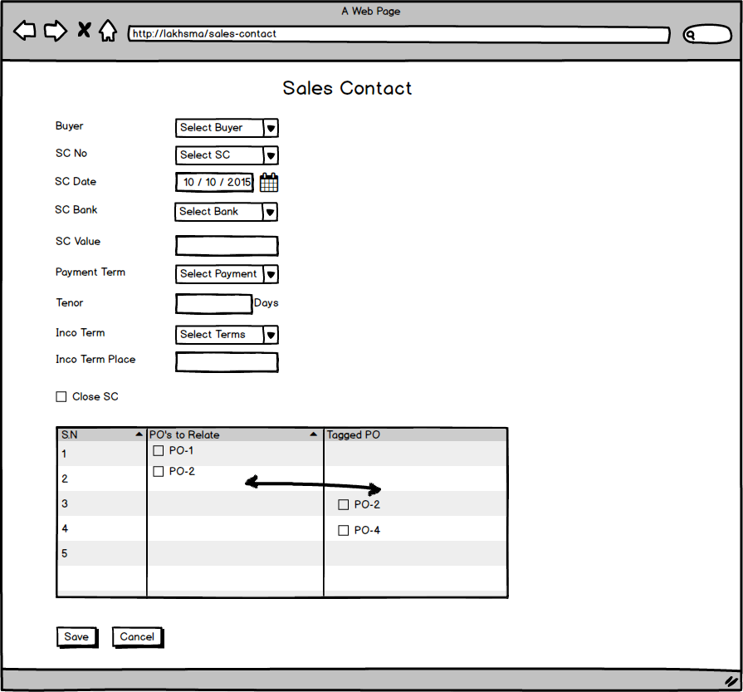

Fig: Sales Contract

## Master LC

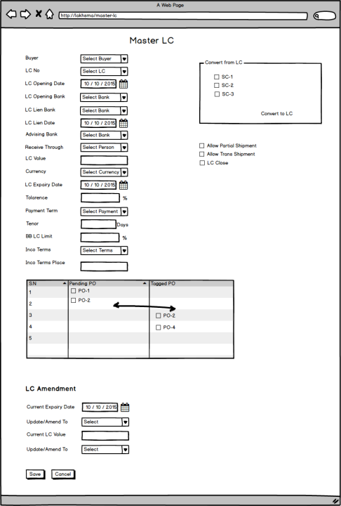

Fig: Master LC

## Export Invoice

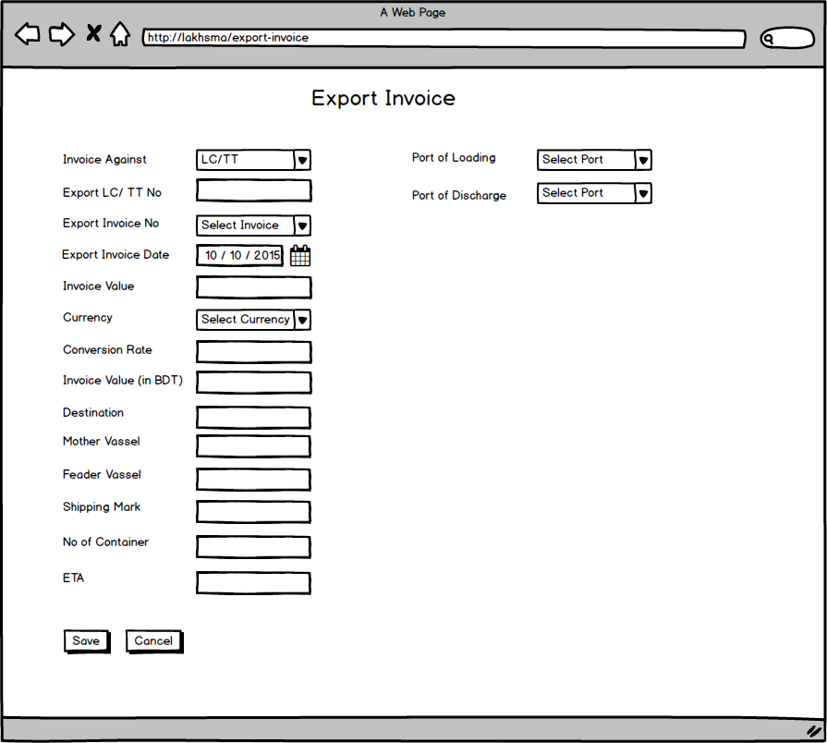

Fig: Export Invoice

## Export Invoice Submission

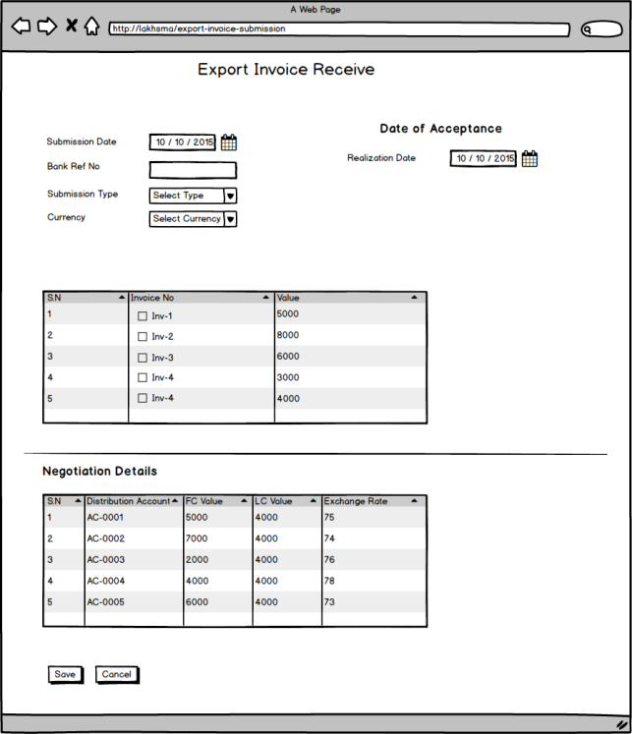

Fig: Export Invoice Submission

## Export Invoice Realization

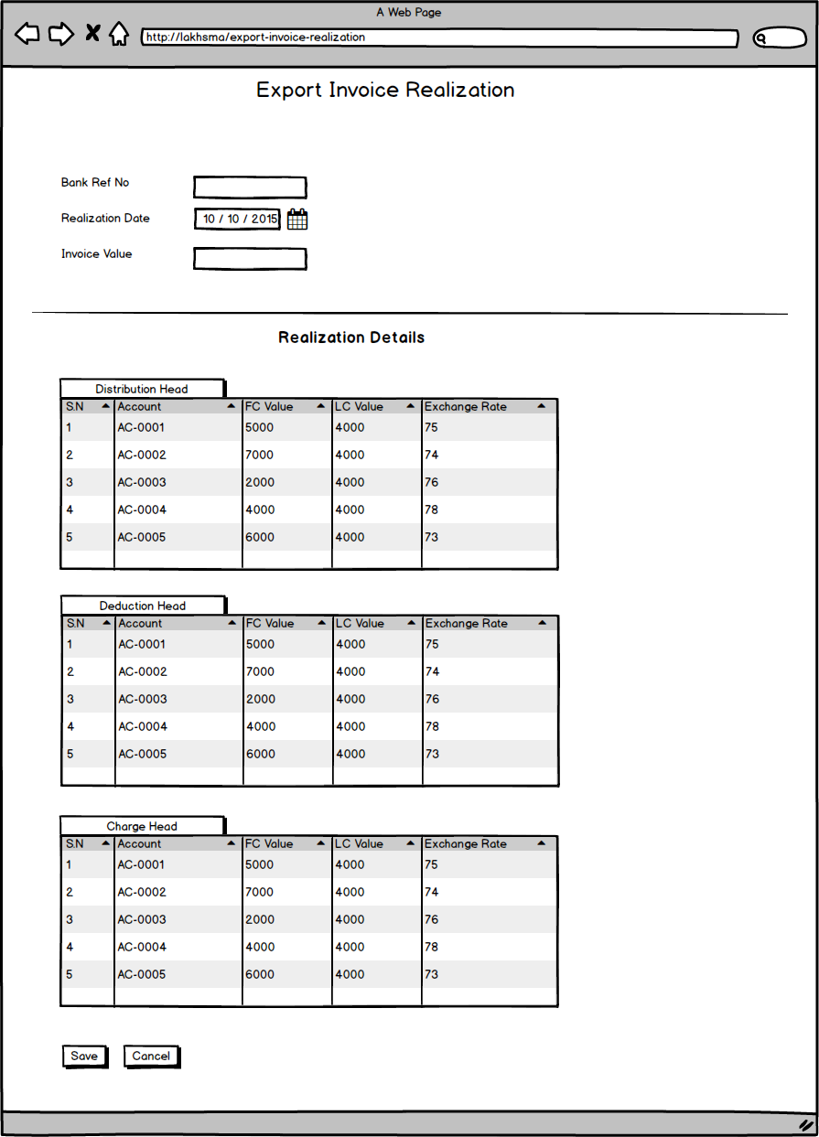

Fig: Export Invoice Realization

## TT Receive

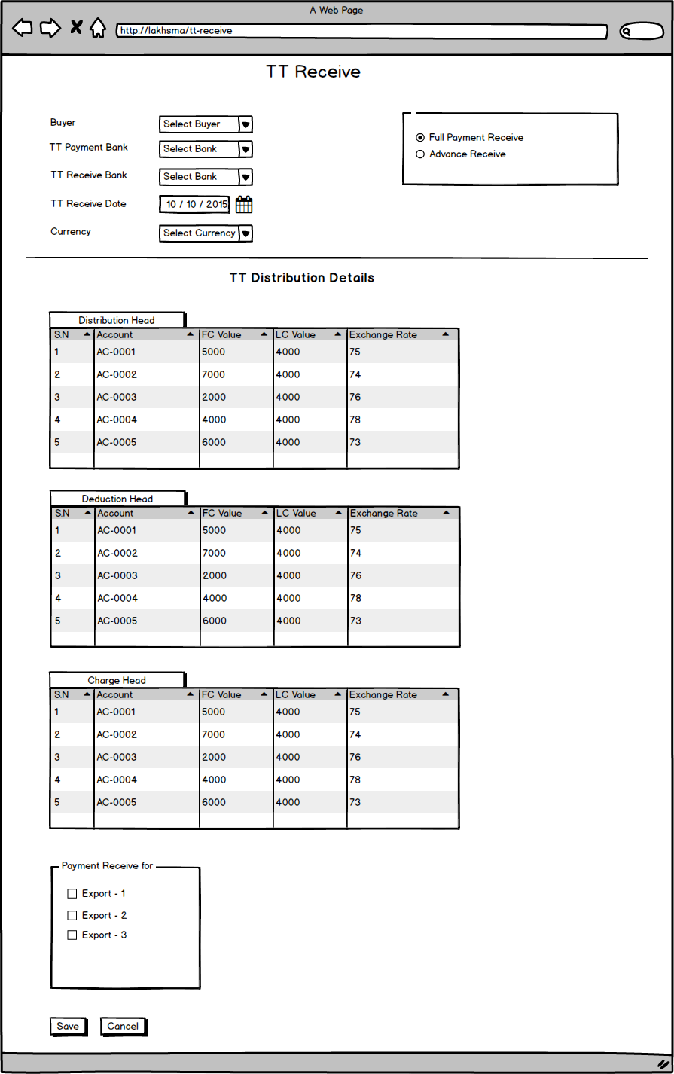

Fig: TT Receive

## Proforma Invoice

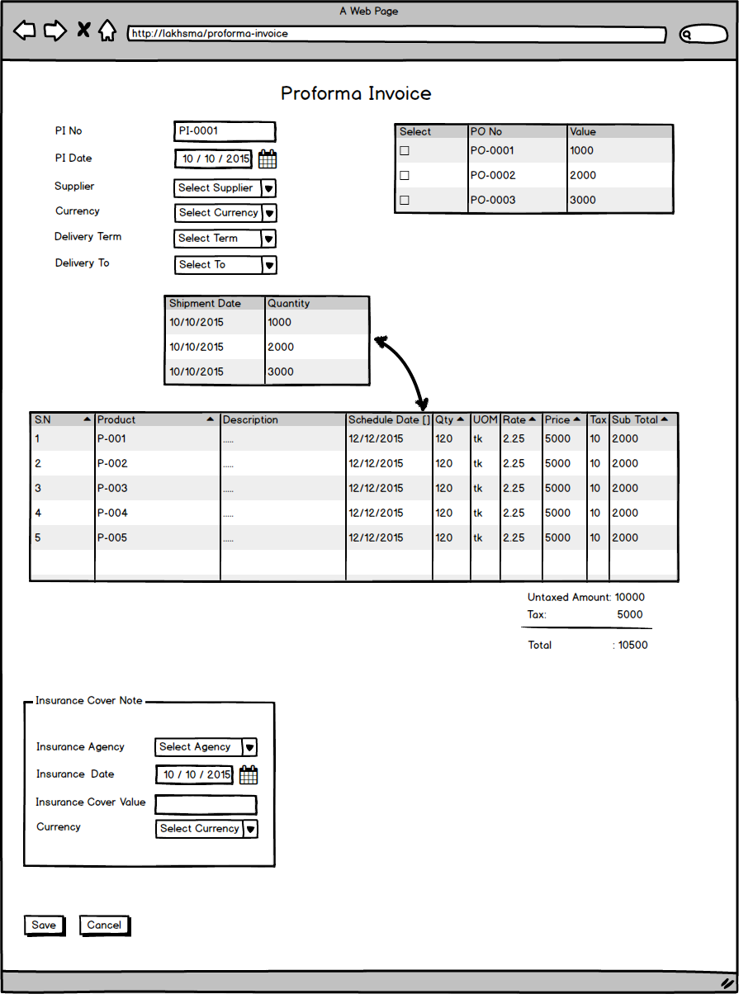

Fig: Proforma Invoice

## BB LC/Import LC

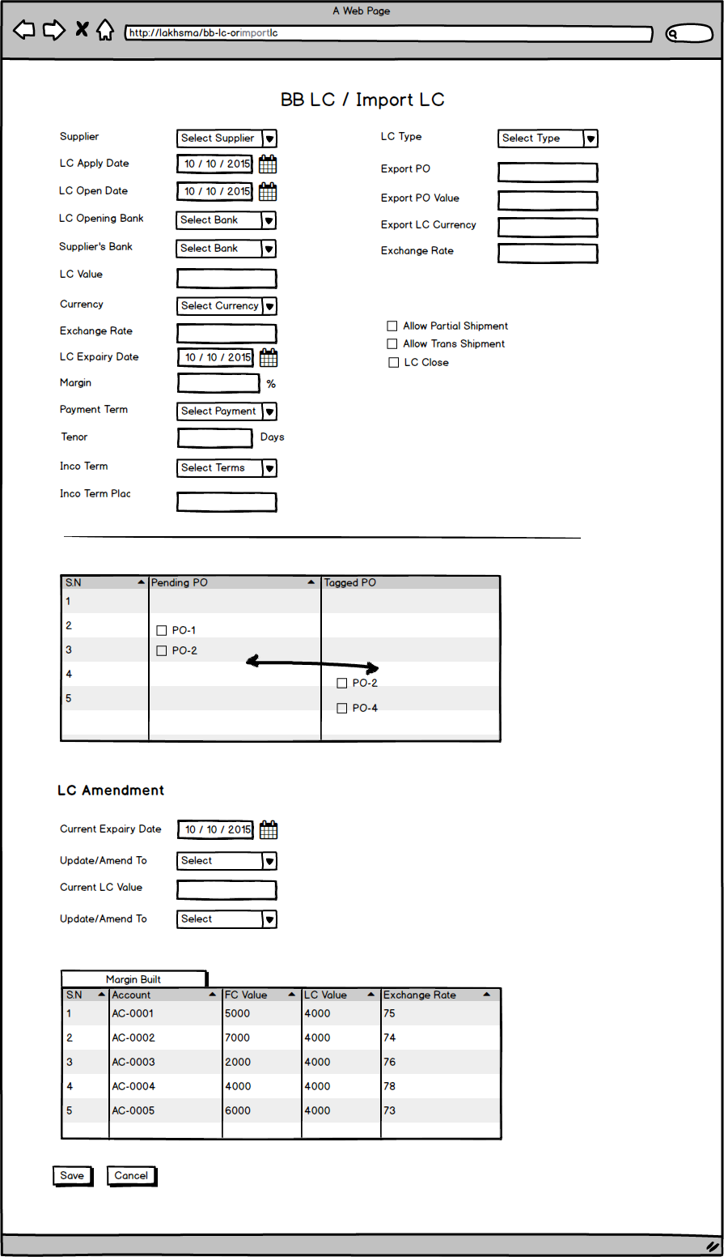

Fig: Pre-costing mock-up

## Import Invoice

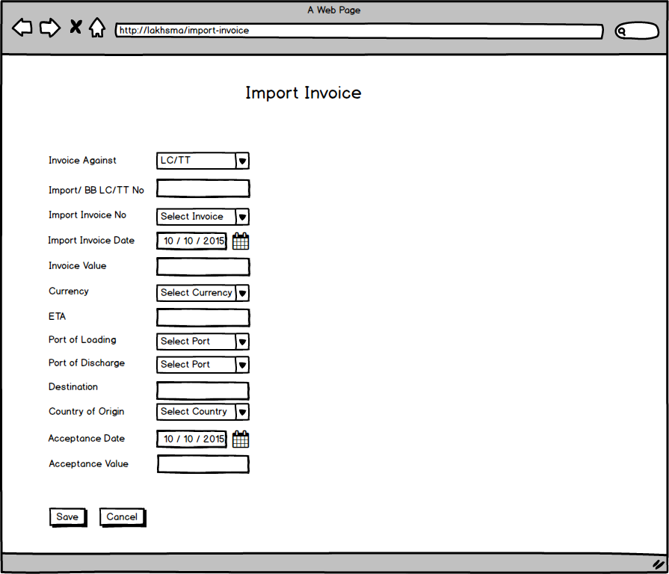

Fig: Import Invoice

## Import Payment

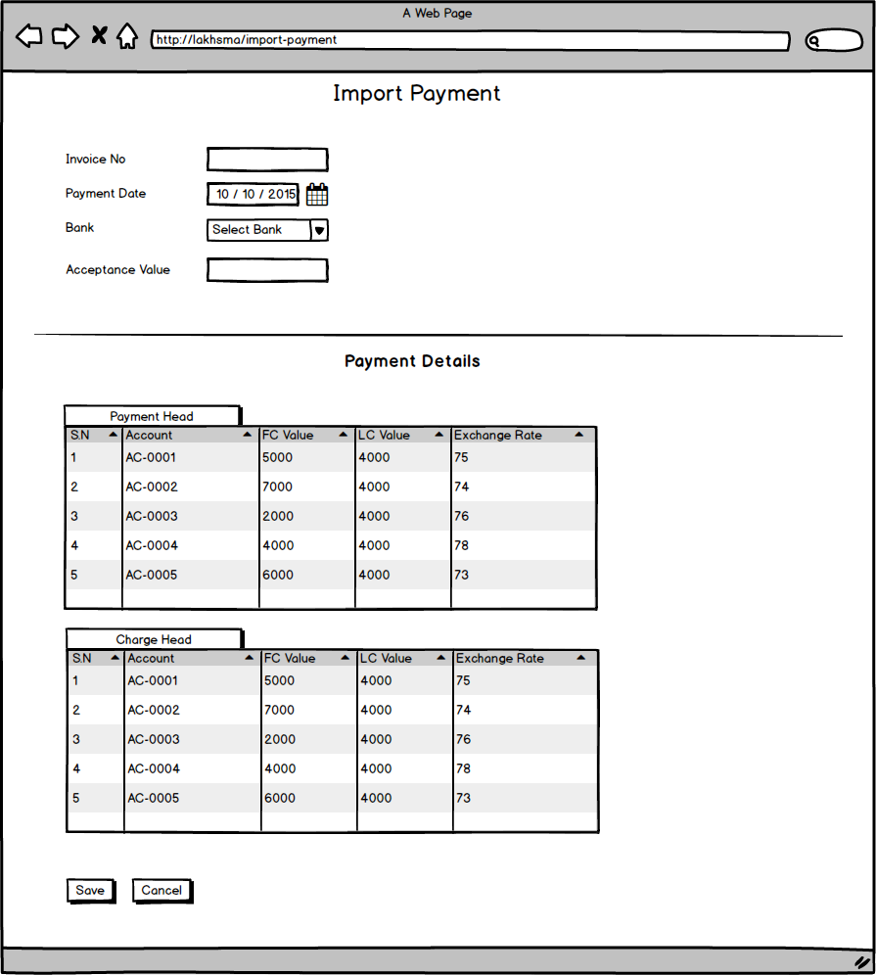

Fig: Import Payment

## TT Payment

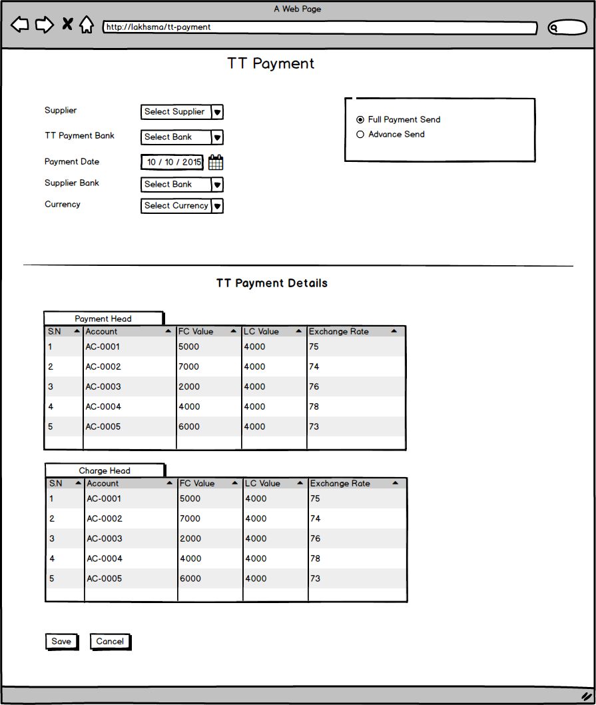

Fig: TT Payment